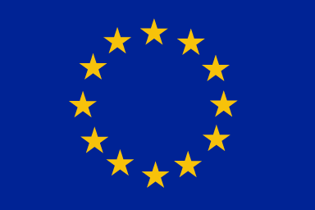 | European Union  Instrument for Pre-accession Assistance  For  Rural Development – IPARD II | 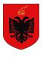
FORECAST NOTICE
FIRST CALL FOR APPLICATIONNo. 01/2018
Under the IPARD II Programme

Agriculture and Rural Development Agency of Albania is announcing the First Call for Application under the IPARD II Programmefrom the Instrument for Pre-Accession Assistance (IPA) for Rural Development (IPARD) with the aim of approving Grants to Agro Food Sector.

The Call is opened for all citizens (natural and legal persons) of Albania who work and operate in the territory of the Republic of Albania in the area of agriculture and rural development with special focus on the following Measures for which applications can be submitted:

Measure 1: “Investments in physical assets of agricultural holdings” with special focus on the following sectors:
- Milk
- Meat
- Fruit
- Vegetables
- Grape

Measure 3: “Investments in Processing and Marketing of agriculture products” with special focus on the following sectors:
- Milk and dairy processing
- Meat processing
- Fruit and vegetable processing
- Wine

Measure 7:“Farm diversification and Business Development”with special focus on the following sectors:

- Production of MAPs, mushrooms, honey, ornamental plants and snails;
- Processing and marketing of wild or cultivated MAPs, mushrooms and honey;
- On-farm processing and direct marketing of agricultural products;
- Aquaculture;
- Nature and rural tourism;
- Services for rural business and population;
- Handcrafts and manufacturing industry;
- Renewable energy production and use.

Under this call the indicative overall available budget is consisted of 50.3 MillionEUR public contribution out which 37.7 Million EUR, as Community contribution representing 75% of the overall public contribution and 12.6 MillionEUR as National contribution representing 25% of the overall public contribution.

The overall indicative budget shall be made available for all measures as following:

Measure 1: with total budget of 21.3 Million EUR, with minimum total eligible investment of 10 000EURO and maximum total eligible investment of 500000 EUR.
Measure 3:with total budget of 20.4 Million EUR, with minimum total eligible investment of 25000 EURO and maximum total eligible investment of 2000000 EUR.
Measure 7:with total budget of 8.3 Million EUR, with minimum total eligible investment of 10000 EUR and maximum total eligible investment of 400 000 EUR.

All interested parties can receive the necessary information concerning types of eligible investments, eligibility of the applicants, criteria for selection and instructions for submitting an applications, in the Guideline for Applicants which can be requested as a free sample hardcopy in the main offices of the Ministry for Agriculture and Rural Development (MARD) andAgriculture and Rural Development Agency (ARDA)during working hours 08:00-16:30h.

Also, the Guideline for Applicants can be downloaded from the following web sites: www.azhbr.gov.al;and http://www.bujqesia.gov.al/a soft version.

This call will be opened from the 30th of November 2018 and shall last for 60 days. The deadline for submission of the application is 30 December 2018

Contact details for further inquiries:
Tel: 0800 83 83
Email: info@azhbr.gov.al

